Lab Manual 6

Part A – INNER JOIN

SQL

SELECT s.Name, d.Department_Name
FROM Student s
INNER JOIN Department d
ON s.Department_ID = d.Department_ID;

OUTPUT

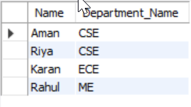

SQL

SELECT s.Name, c.Course_Name
FROM Student s
INNER JOIN Course c
ON s.Student_ID = c.Student_ID;

OUTPUT



Part B – LEFT JOIN

SQL

SELECT s.Name, d.Department_Name
FROM Student s
LEFT JOIN Department d
ON s.Department_ID = d.Department_ID;

OUTPUT

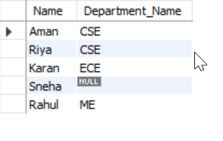

SQL

SELECT s.Name, c.Course_Name
FROM Student s
LEFT JOIN Course c
ON s.Student_ID = c.Student_ID;

OUTPUT

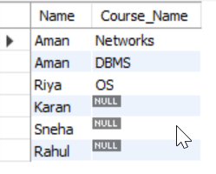

Part C – RIGHT JOIN

SQL

SELECT s.Name, d.Department_Name
FROM Student s
RIGHT JOIN Department d
ON s.Department_ID = d.Department_ID;

OUTPUT

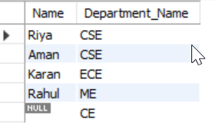

SQL

SELECT s.Name, c.Course_Name
FROM Student s
RIGHT JOIN Course c
ON s.Student_ID = c.Student_ID;

OUTPUT
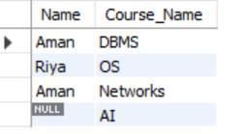

Part D – FULL OUTER JOIN

SQL

SELECT s.Name, d.Department_Name
FROM Student s
LEFT JOIN Department d ON s.Department_ID = d.Department_ID
UNION
SELECT s.Name, d.Department_Name
FROM Student s
RIGHT JOIN Department d ON s.Department_ID = d.Department_ID;

OUTPUT

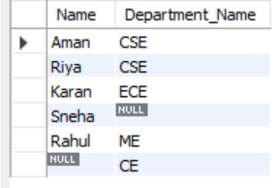

SQL

SELECT s.Name, c.Course_Name
FROM Student s
LEFT JOIN Course c ON s.Student_ID = c.Student_ID
UNION
SELECT s.Name, c.Course_Name
FROM Student s
RIGHT JOIN Course c ON s.Student_ID = c.Student_ID;

OUTPUT


Part E – SELF JOIN

SQL

CREATE TABLE Employee (
Emp_ID INT PRIMARY KEY,
Name VARCHAR(50),
Manager_ID INT
);

INSERT INTO Employee VALUES
(1, 'A', NULL),
(2, 'B', 1),
(3, 'C', 1),
(4, 'D', 2);

SELECT e.Name AS Employee, m.Name AS Manager
FROM Employee e
LEFT JOIN Employee m
ON e.Manager_ID = m.Emp_ID;

OUTPUT

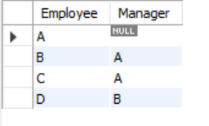

Part D – Advanced Queries

SQL

SELECT d.Department_Name, COUNT(s.Student_ID) AS Student_Count
FROM Department d
LEFT JOIN Student s
ON d.Department_ID = s.Department_ID
GROUP BY d.Department_Name;

OUTPUT

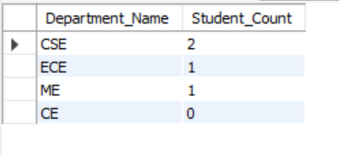

SQL

SELECT s.Name, COUNT(c.Course_ID) AS Course_Count
FROM Student s
JOIN Course c ON s.Student_ID = c.Student_ID
GROUP BY s.Name
HAVING COUNT(c.Course_ID) > 1;

OUTPUT

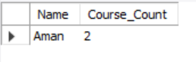

SQL

SELECT d.Department_Name
FROM Department d
LEFT JOIN Student s
ON d.Department_ID = s.Department_ID
WHERE s.Student_ID IS NULL;

OUTPUT

